## PROJECT DEVELOPMENT PHASE DELIVERY OF SPRINT-1

|  |  |
| --- | --- |
| DATE: | 29 OCT 2022 |
| TEAM ID: | PNT2022TMID39958 |
| PROJECT: | AI-powered Nutrition Analyzer for Fitness Enthusiasts |
| MAXIMUM MARKS: | 4 Marks |

**IDENTIFYING THE PROBLEM STATEMENT:**

It is necessary to identify the problem for any problem. In our project the problem we are trying to overcome obesity by using Nutrition Analyzer for fitness enthusiasts

## UNDERSTANDING THE PROJECT OBJECTIVES:

Identifying the method to solve the problem. Selecting the best the algorithms, software and technology to develop an application that enables Nutrition Analyzer for fitness enthusiasts

## FINDING BASE PAPERS FOR REFERNCE:

Look for base papers that were previously published that aimed at solving similar problems.

Try to take adaptations from it and makes modifications for the drawbacks of the previous papers.

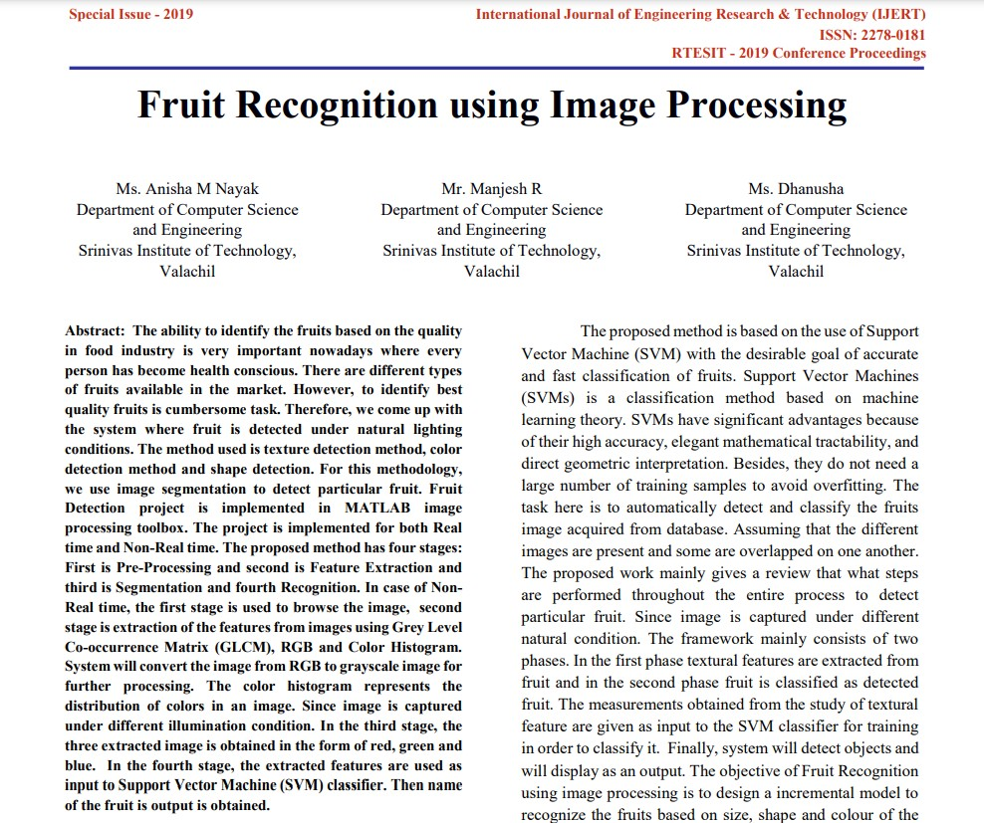

# LITERATURE SURVEY:

Collecting as many related papers to our project. Trying to understand the algorithm and method they used, searching for alternate methods to implement our project.

**EMPATHY MAP:**

Analyze the problem properly and the categories the aim of the project into;

1. What we see?
2. What we think and feel?
3. What we hear?
4. What we say and do?
5. Pain and gain

